Writeup to explain how to run the microservices and sample URLs to hit each of your service endpoints.

Assumption:

* Before running the project ,create database as BANKAPP and configure in APPLICATION.PROPERTIES according to your system.

|  |  |
| --- | --- |
| **SERVICE NAME** | **SERVER PORT** |
| Eureka Server | 8761 |
| API-Gateway | 8999 |
| BANKAPP(Customer Micro Service) | 9001 |
| BANKAPP2(Account Micro Service) | 9002 |
| Config Server | 8085 |

* **How to run microservice?**

1. Firstly ,You can Run EUREKA server so that microservices register with this.
2. Then ,run config server to attach application.properties file with microservices.
3. Now run the microservices accordingly.

**How to hit url’s of Microservices:**

1. You can run both ways like through API-gateway port or with the microservice port.
2. Get ALL customers

1. Get customer by ID

Method: GET

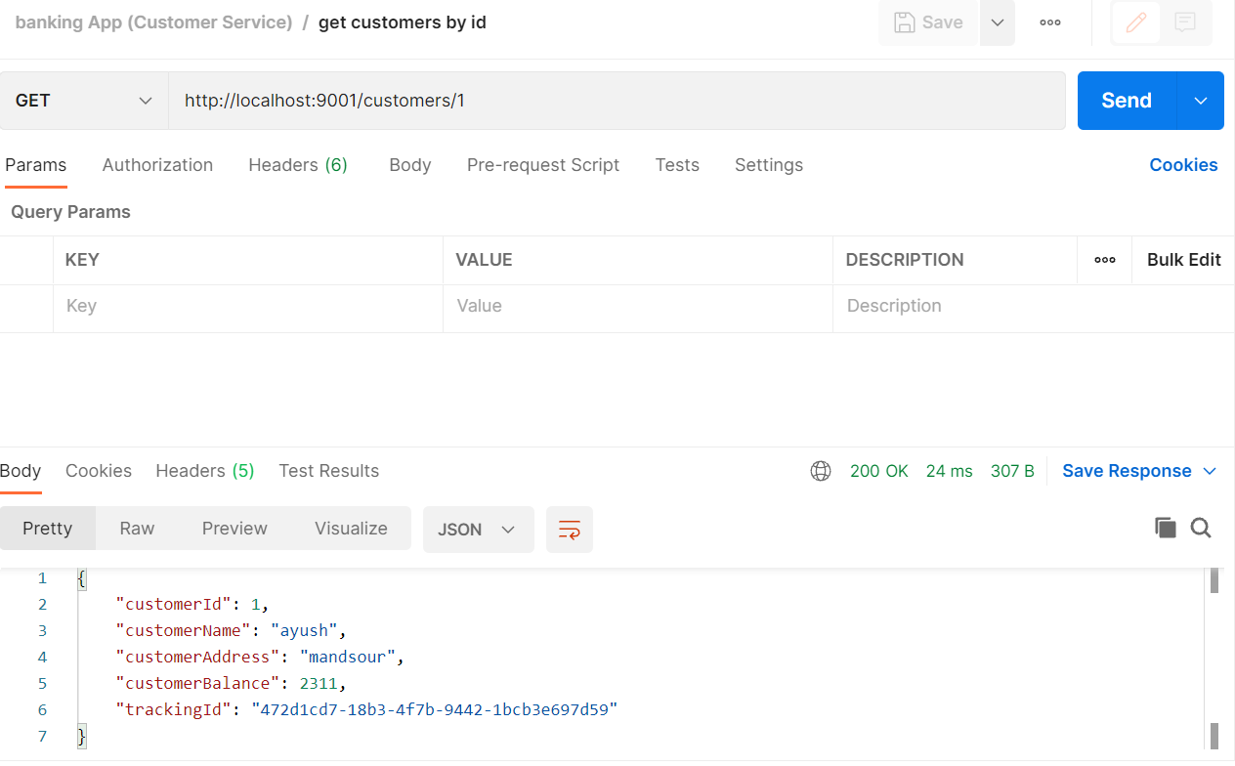

1. **ADD customer**

**Method: POST**

1. **UPDATE customer**

**Method: put**

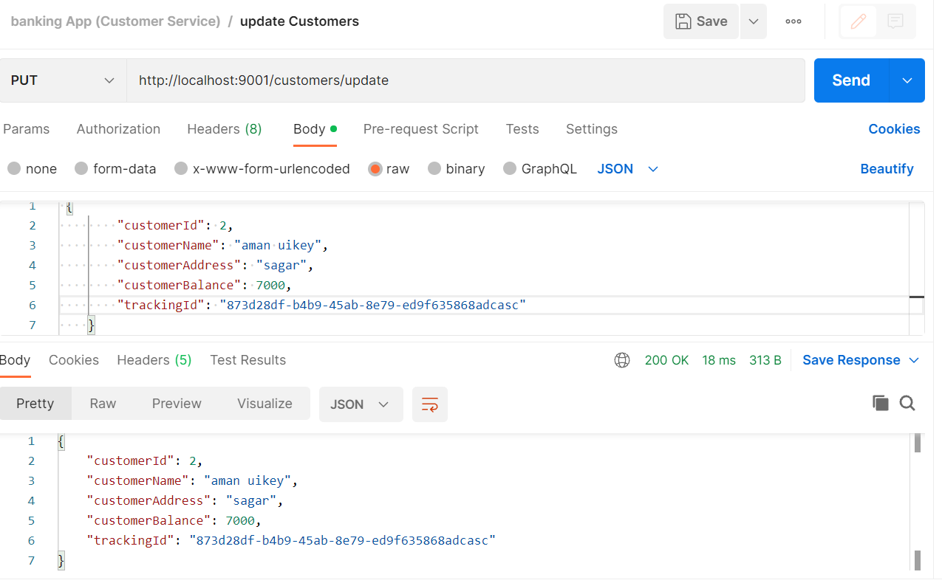

1. DELETE customer by ID

Method: DELETE

1. Get All Account

Method: GET

1. Get Account by ID

Method: GET

1. **ADD customer**

**Method: POST**

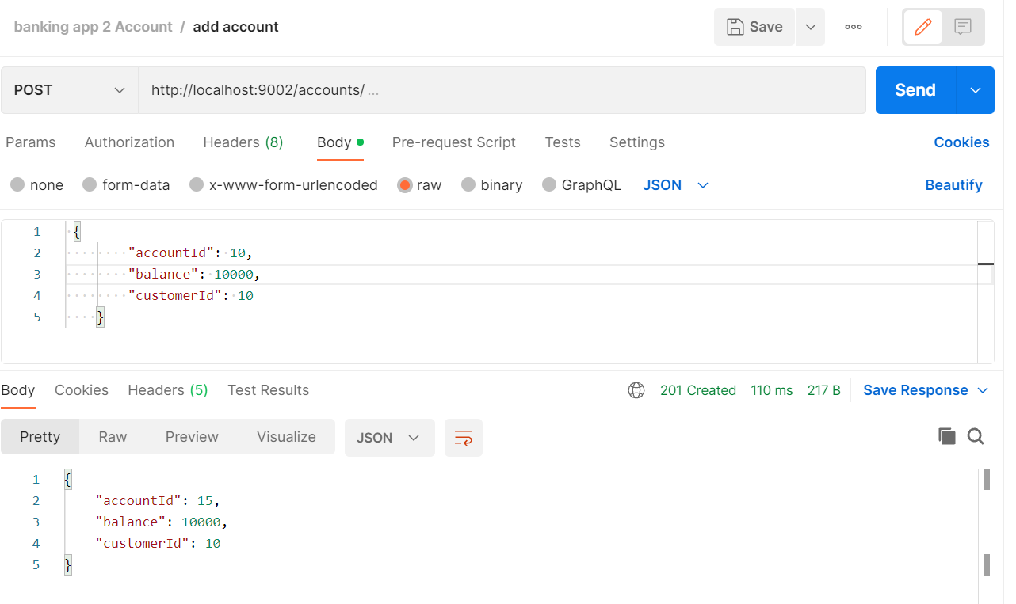

1. **DEPOSITE Money from account**

**Method: PUT**

1. **Withdraw Money From Account**

**Method: PUT**

1. **Delete Account**

**Method: DELETE**

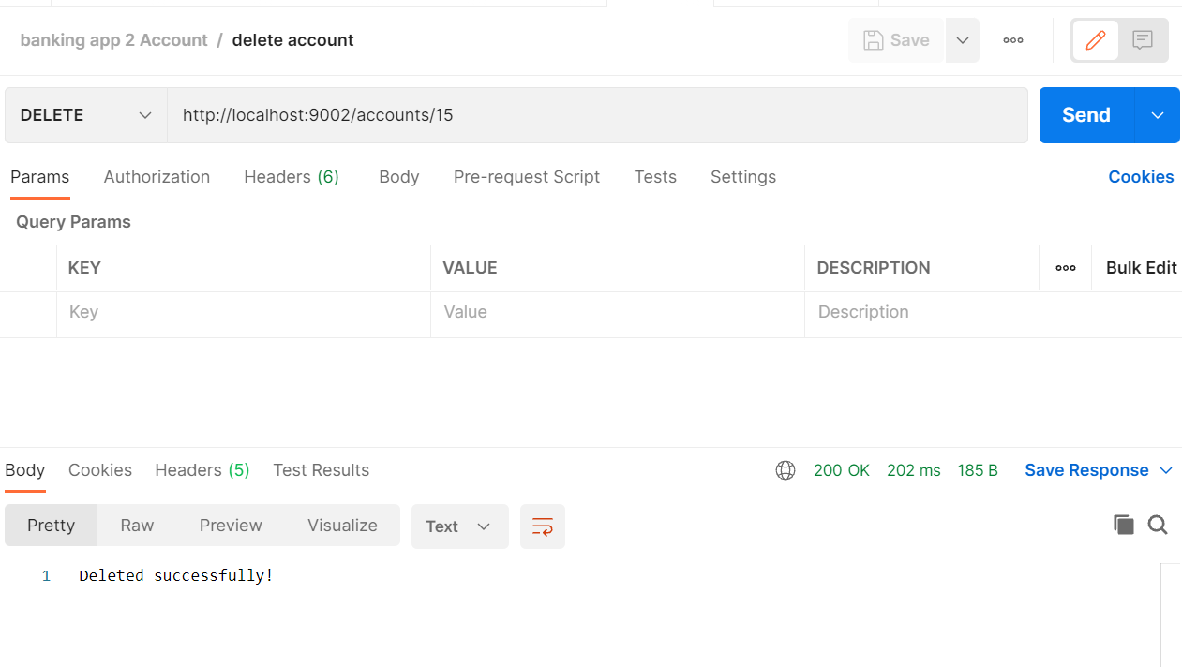

1. **EUREKA SERVER**

**Port : 8761**

1. Get All Customer with API gateway

Method: get

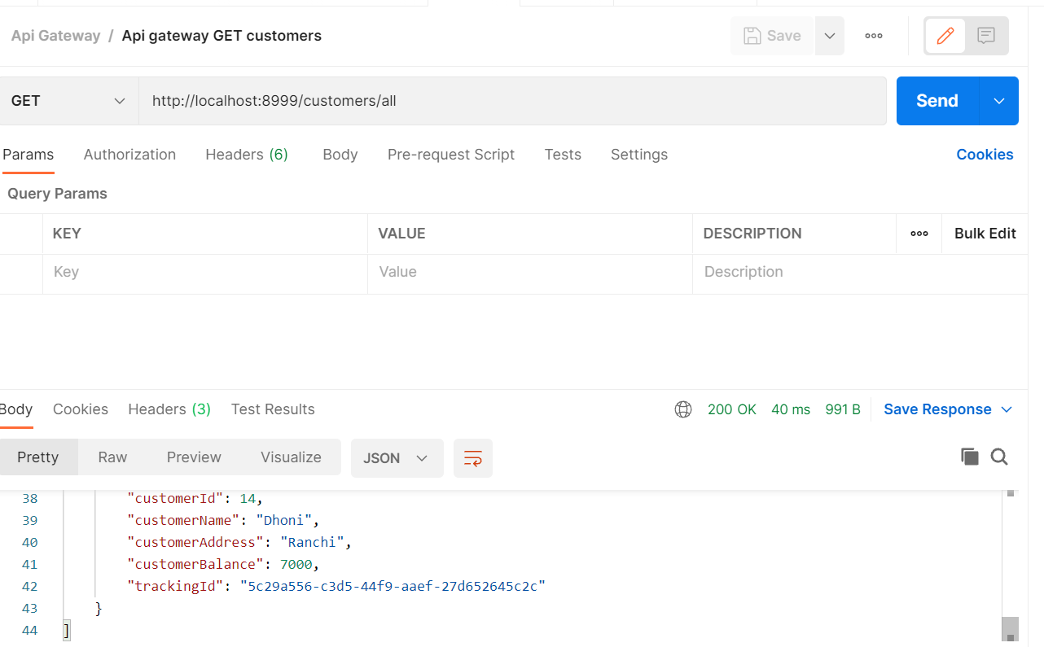

1. **Get All Account with API gateway**

**Method: get**

**Now, we can run all microservices with the help of API gateway which port number is 8999 , and acquire properties from GITHUB with CONFIG server.**